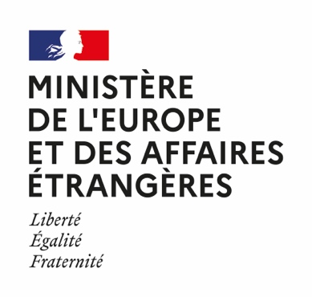 | 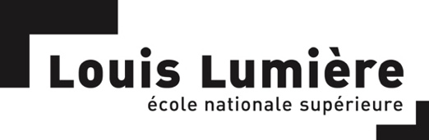 |  | Candidate photo

Summer programme 2022

École nationale supérieure Louis-Lumière
with the support of the
French Ministry for Europe and Foreign Affairs

July 11th - August 19th 2022

APPLICATION FILE

PERSONAL INFORMATION:

Surname:
First name:
Nationality:
Permanent Address:
Country/Region:

Street:

City:

State:
Postal Code:

Personal situation:
Student
Name of the School / Department / Major
Year of study:

Young professional
Function:
Company:
Field of activity:

Other:

Date of birth:
Age:

Cell phone number: +

E-mail:
Skype:

CV

Diploma:

Year | Diploma / Name of the school/university | Grade | Description

Other:

Year | Name of the school | Description | Duration

Professional experience:

Year | Name of the entity | Description (function)

YOUR INTEREST IN THIS WORKSHOP
Please note that these elements are meant to help the jury assess your familiarity with sound practices. However, this workshop will not be dedicated to carrying out personal projects.

- Do you listen to radio documentaries? If so, please specify where – radios, web radios, podcasts, festivals, etc.

- Have you already produced a radio / podcast work, or a creative work involving sound? Or any kind of audiovisual work?
If so, please submit link.

- Do you currently have a radio / podcast project, or a creative project involving sound? If so, please provide a 1-page synopsis.

- In your opinion, what impact will your stay in France have on your professional career?

- How do you imagine your career in 5 years? Be precise.

YOUR LANGUAGE SKILLS
ENGLISH……. | A1/A2 | B1/B2 | C1/C2 | Bilingual
FRENCH…… | A1/A2 | B1/B2 | C1/C2 | Bilingual

Have you ever been to France? If so, why and for how long? Tourism, linguistic stay, studies?

Sound recording skills (specify equipment)
Equipment: ……….
Level | Very good | Good |  | Medium | Poor

Use of sound editing software (specify software)

Software: ……….
Level | Very good |  | Good | Medium | Poor

Documents to be attached to this form :
All documents including this form must be gathered in one pdf

- CV (1 page) (in English)

- A cover letter (in English) explaining the various reasons why you are applying for this workshop (1 page)

- A 1-page synopsis of your current sound-based project (if relevant)

- An ID photo in digital format, to be inserted at the top of the initial page of this file.

