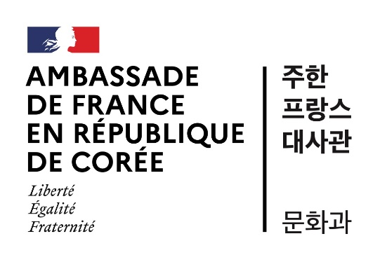

Call for proposals
***
STAR-T exploratory mission program
2025
The STAR-T exploratory mission program is a funding program implemented by the Scientific and Academic Service of the French Embassy in the Republic of Korea, aimed at researchers from French institutions. Its goal is to enable researchers in France wishing to establish initial contact with Korean research teams in their areas of expertise to initiate new bilateral collaborations.
The call for proposals is open to all scientific fields, including humanities and social sciences. However, priority will be given to projects related to the following areas: health, biotechnology, artificial intelligence, quantum sciences, marine sciences, and materials science.
The potential for future European projects, particularly those under Horizon Europe, is an asset that should be clearly highlighted.
- Nature of projects:
The program supports scientific missions to the Republic of Korea in 2025 by researchers based in a French research institution.
Missions that also include visits to Korean academic partners with the aim of initiating/formalizing institutional partnerships, such as student mobility, double degrees, etc., are eligible.
- Project eligibility criteria:
The call for projects is open to researchers/lecturer-researchers belonging to laboratories attached to higher education establishments, research organizations, or French companies. Students are not eligible.
- Project selection criteria:
Applications will be assessed according to the following criteria:
- Scientific excellence of the applicant and the field
- Quality of the project (innovative nature, complementarity of skills, quality of invitation letters, etc.)
- Relevance of the proposed mission to the Republic of Korea in terms of the future collaboration envisaged.
- Terms and conditions of support:
The support granted to each winner will include the cost of a round trip plane ticket from France to the Republic of Korea.
As the funding is granted on an annual basis, the allocated budget must be used before 31 December 2025 and cannot be carried over to the following year (2026). The end date of the mission (return flight) must therefore be set before 31 December 2025.
- Organization and follow-up of projects:
A partnership agreement, drafted by the Institut français de Corée du Sud, is sent to the selected candidate. This agreement must be signed by the researcher’s affiliated institution and returned to the Institut français de Corée du Sud. Once the agreement has been signed by both parties, the researcher’s affiliated institution advances the purchase of the plane tickets. The Institut français de Corée du Sud then reimburses the cost upon receipt of the purchase, supported by an invoice.
No air tickets booked in advance by individual laureates will be reimbursed.
The final program for the mission must be sent to the French embassy in the Republic of Korea before departure.
An end-of-mission report must be sent to the French Embassy no later than one month after the end of the mission.
- How to apply:
- Opening date of the call for applications: December 20, 2024
- Deadline for submission of applications: March 1st, 2025
- The results will be announced at the end of March, except for projects requiring an earlier start. Therefore, please clearly specify in both the application file and the email body if the project needs to begin before March 31, so it can be prioritized for expedited evaluation.
Applications must be submitted by sending all the documents listed below to the French Embassy in the Republic of Korea electronically at the following address: star-t@kr.ambafrance-culture.org
- an application file (in French or English) in Word and PDF format, to be downloaded from the website of the French Embassy in the Republic of Korea;
- a Curriculum Vitae in French or English (2 pages maximum);
- Letter(s)/e-mail(s) of invitation or support in French or English from the laboratory(ies)/researcher(s) you wish to visit in the Republic of Korea.
When submitting your application, please state explicitly in the subject line of the email your surname, first name, and the acronym corresponding to your field of research as mentioned in the application file. eg. LAST NAME First name (acronym) - STAR-T 2025 application
The application will be effective after receipt of an acknowledgement e-mail.
- Contacts for the program:
Scientific and University Service - French Embassy in the Republic of Korea
43-12 Seosomun-ro, Seodaemun-gu, Seoul, 03741, Republic of Korea
E-mail: star-t@kr.ambafrance-culture.org

